Dapp V1.0 project functionality diagrams

Login

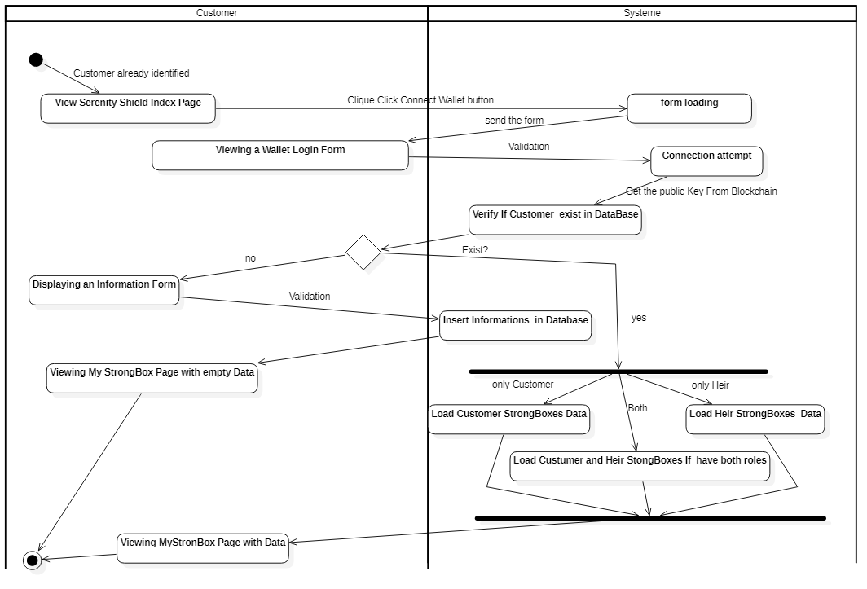

General operation of the creation of a StrongBox

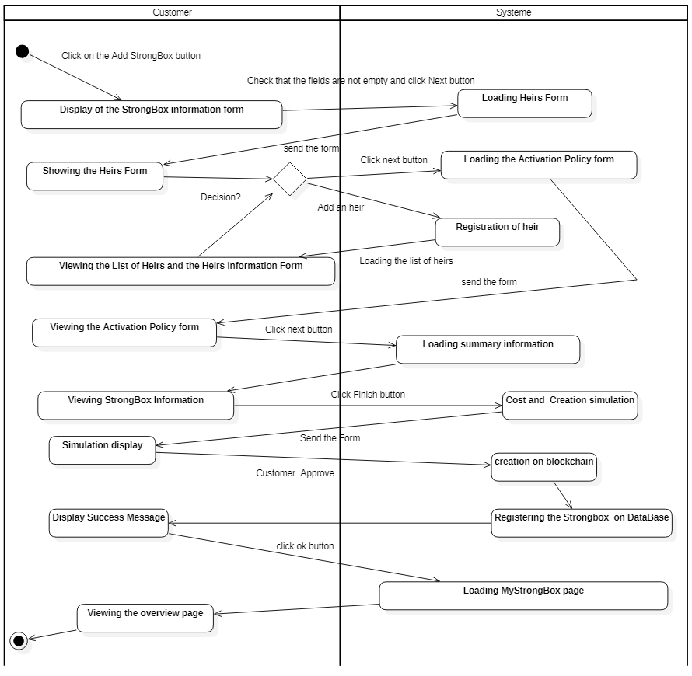

Step 1 StrongBox Information

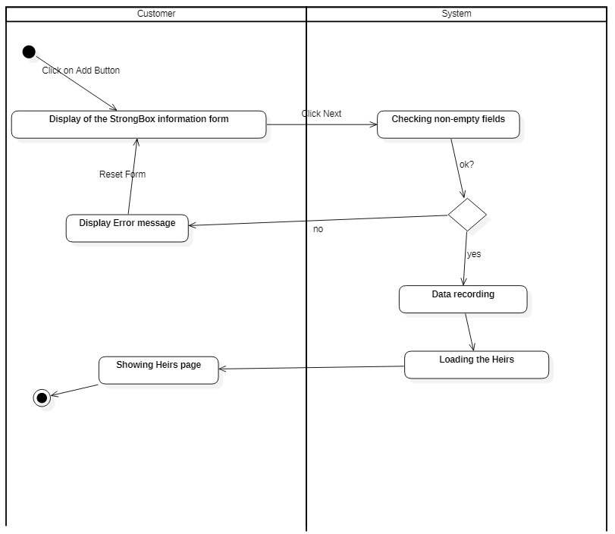

Step 2 Heir Information

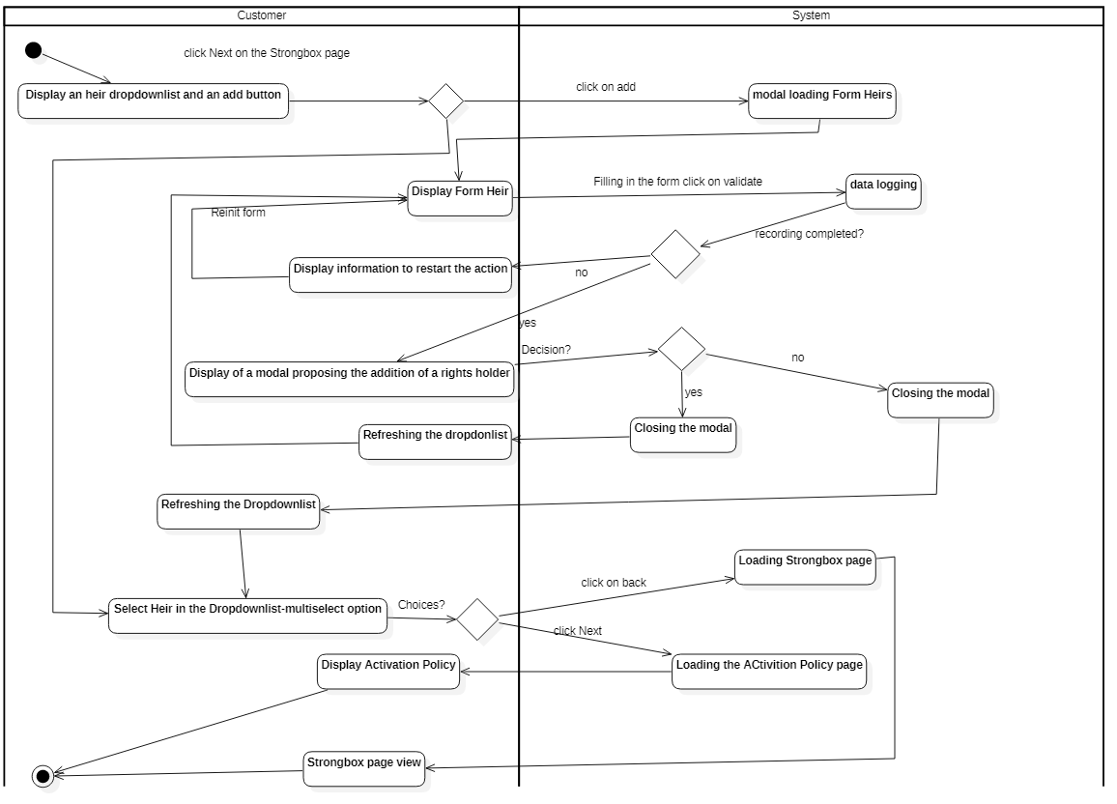

Step 3 Activation Policy

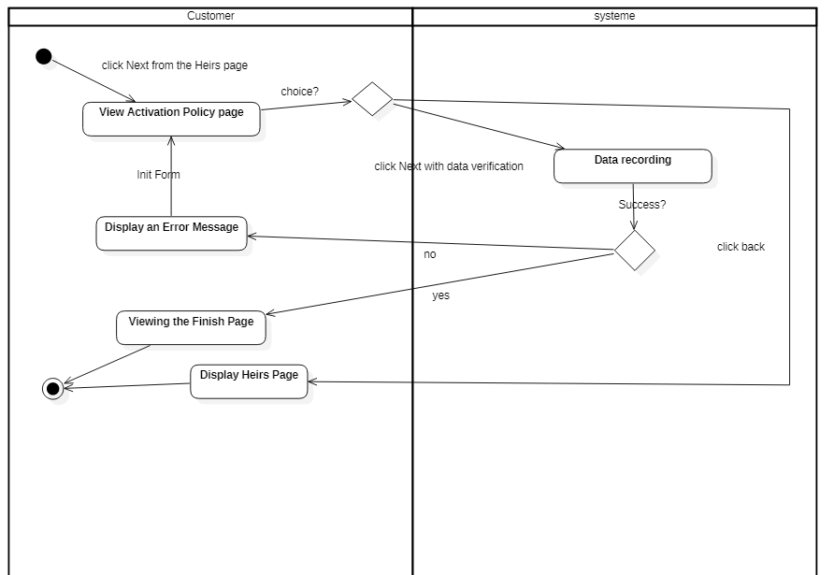

Step 4 Finalization

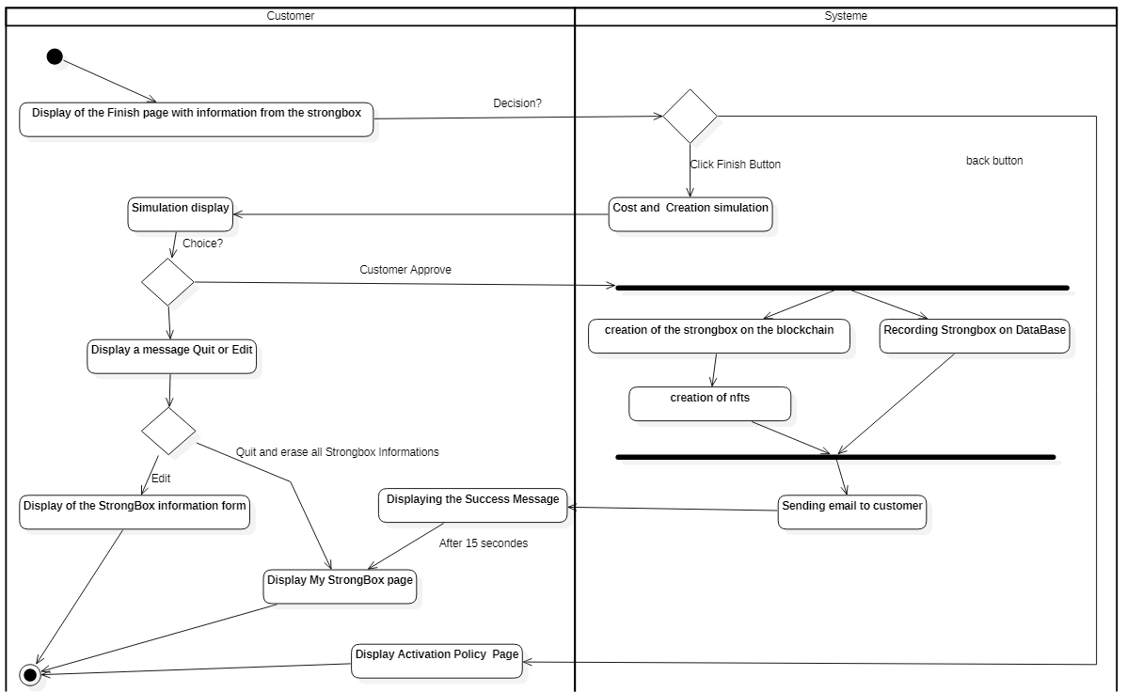

Creation of heirs by the Heir Menu

For this part I recommend using a table with the following functionalities: view, add, modify and delete.

To see the information of an heir, just click on the row

Diagram 1 adding an heir

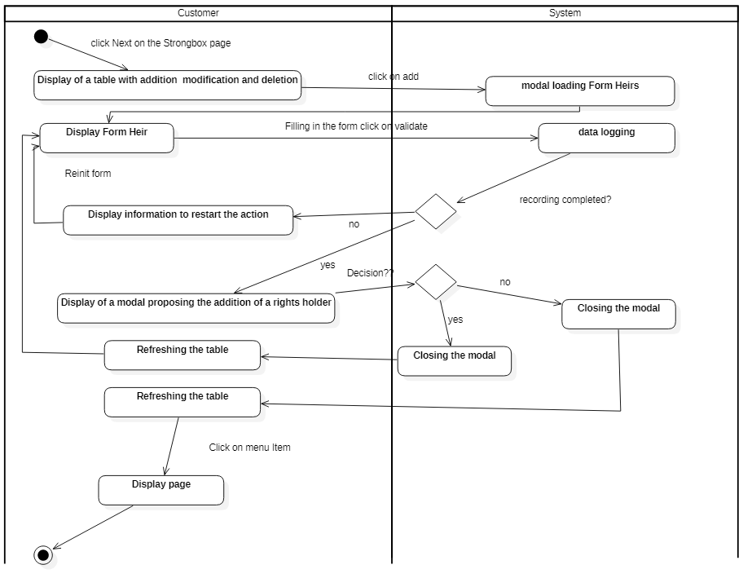

Diagram 2 updating an heir

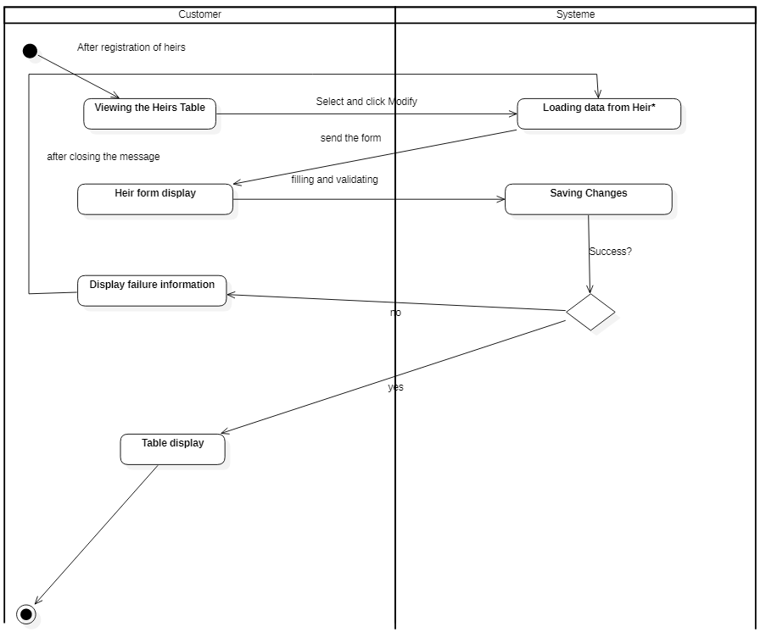

Diagram 3 deletion of an heir

